Assignment 3

Name: Lukas Pfalz

CSC-1110

Section: CSC-1110-71762

# **Assignment 3**

***COMPLETE THE HONOR CODE BELOW***

**HONOR CODE:**

I pledge that this program represents my own program code, I have received help from no one and I have given help to no one.

**OR**

I received help from **NAME OR NO ONE** in designing and debugging my program.

I have given help to **NAME OR NO ONE** in designing and debugging my program.

This assignment is required.

The grading form shows point values for this assignment. Please review it now.

Show screen shots of the python code with comments and your input/output window.

You should use several well-planned sets of data to check out your program. Testing your programs with just the data that is asked for in the assignment does not necessarily mean that the programs will work for all cases.

Please include the following comments in each of your Python programs:

Your Name

Section

Date

Description

Assignment Number

A python template (python_template.py) has been provided for you to use.

Name this document XXX_Assignment 3 where XXX are your initials. Include a python file named P01.py, P02.py, etc. for each problem.

## Design a program to calculate a student’s letter grade on 3 exam scores. The table below shows the equivalent letter grade for the corresponding average score you calculate. Run this problem using the numerical grades of 58, 73 and 90. Show screen shots of the PYTHON program, all input and output. Save this program.

The scores must be entered when running the program. They should not be hardcoded in the code itself.

|  |  |
| --- | --- |
| Numerical Grade | Letter Grade |
| Below 60 | F |
| Between 60 and 70 (including 60) | D |
| Between 70 and 80 (including 70) | C |
| Between 80 and 90 (including 80) | B |
| 90 and greater | A |

Display numerical grade and letter grade on the output.

Sample input/output:

Three Exam Score Grade Calculator

Enter exam 1 score: 58

Enter exam 2 score: 73

Enter exam 3 score: 90

Results:

Average of the 3 scores: 73.67

Letter grade: C

**PLACE SCREEN SHOTS OF THE PYTHON CODE AND ALL I/O BELOW.**

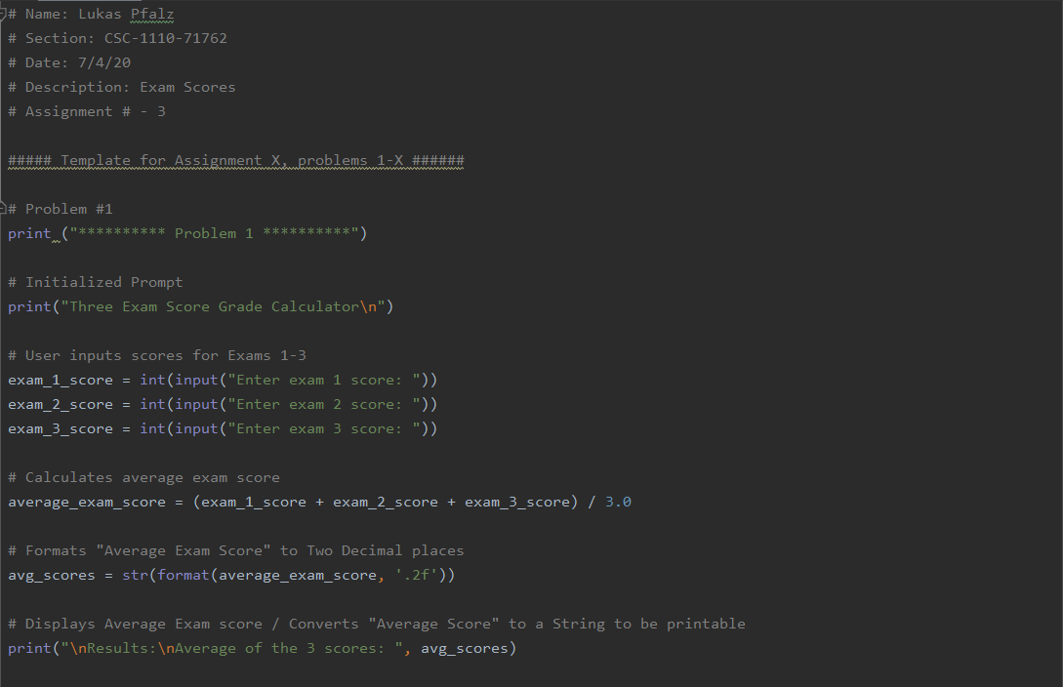

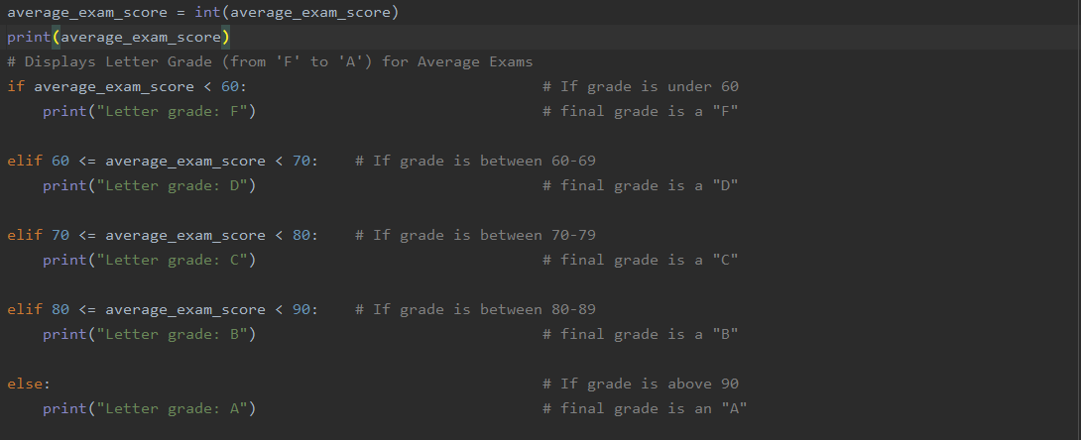

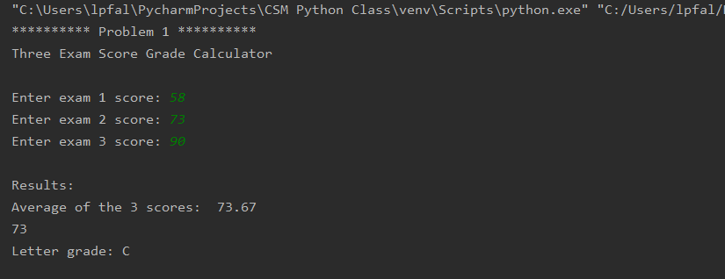

## Design a program that inputs three values (x, y and z) and displays the smallest integer. **Run this problem using x = 19, y = -3 and z = 8**.

The values must be entered when running the program. They should not be hardcoded in the code itself.

Here is a sample running of the program:

Display the smallest of three integers

The value of x is: 19

The value of y is: -3

The value of z is: 8

The smallest value is -3

Comment your source code and describe your code to someone who may be viewing it for the first time.

**PLACE SCREEN SHOTS OF THE PYTHON CODE AND ALL I/O BELOW.**

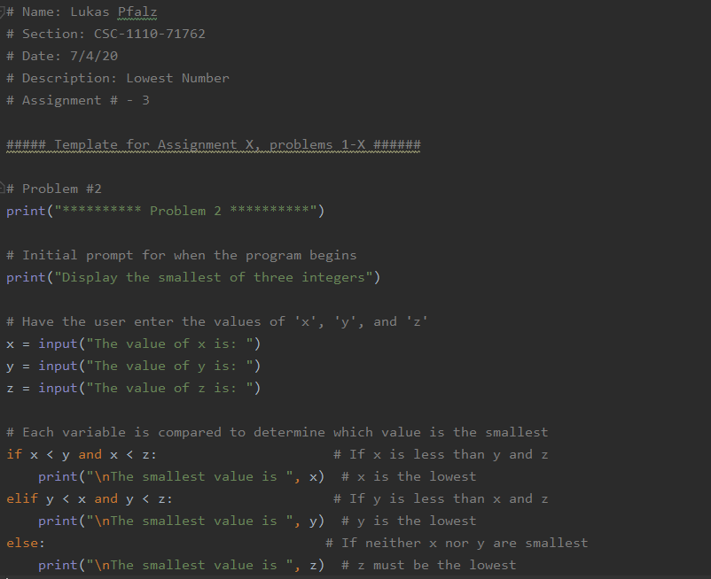

## 

## Write a program that will calculate a person’s pay for a week. Input the hourly pay rate and the number of hours worked; output the pay in a neat formatted manner. They will be paid overtime (at a time and one-half rate) for all hours worked over forty hours. For example, if they work 50 hours and their pay rate is 10.00 / hour, their pay will be $550.00.

## Run this program with the following:

## hours worked = 42 and hourly pay rate = 9.65

## hours worked = 38 and hourly pay rate = 10.35

Output your results as follows.

Weekly Pay Calculator

Enter the employee’s hours worked this week: 40

Enter the employee’s hourly pay: 10.50

The employee’s pay: $420.00

Comment your source code and describe your code to someone who may be viewing it for the first time.

**PLACE SCREEN SHOTS OF THE PYTHON CODE AND ALL I/O BELOW.**

